AWS Database:

Two main databases we are going to cover in AWS database. Here we will learn how to launch the data base, how to scale up and scale out and how to manage redundancy.

1. Amazon Relational Database Server (RDS): such as MySQL, Microsoft SQL Server.
2. Amazon Dynamo DB: Amazon own database and it is (non relational database)

**Amazon RDS Overview:**

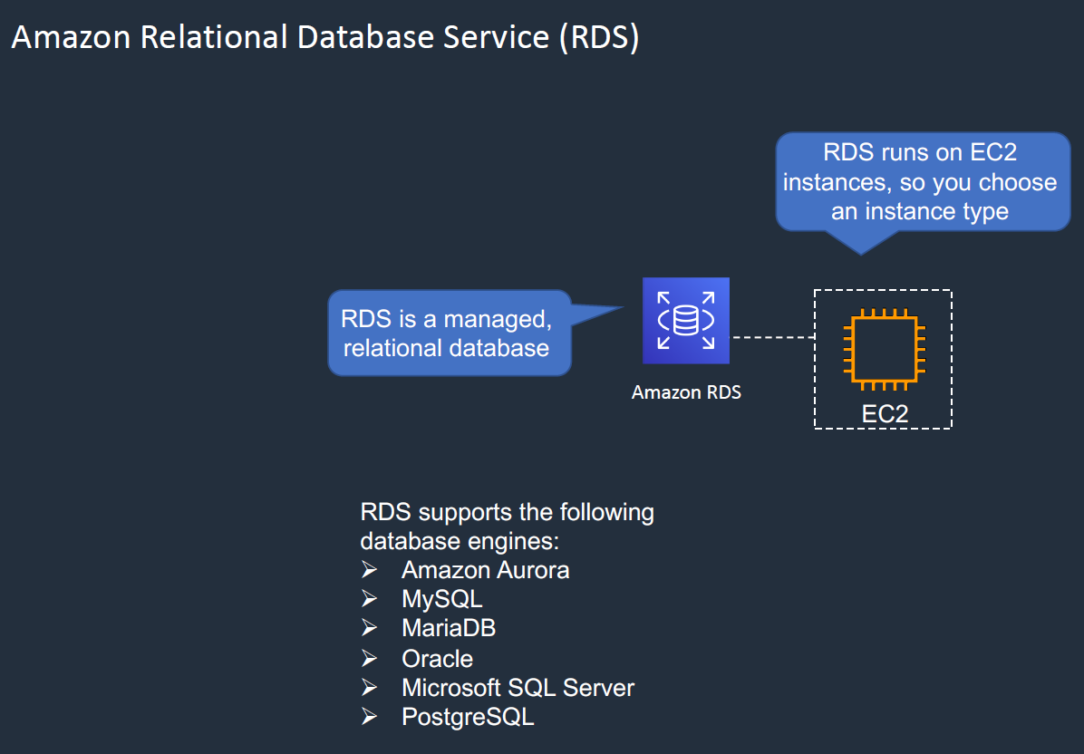

1. It is Amazon Relational Database Service(RDS)
2. It manages relational database like MYSQL, MicrosoftSQL etc
3. RDS run on Amazon EC2 instances, so when we launch RDS database then we have to choose EC2 instances according to our need and cost is also comes according to EC2 instance that we have selected because each EC2 contains different type of configuration like RAM, HDD.
4. We can change the instance type any time if does not want any down time.
5. RDS supports the following database engine

- Amazon Aurora: This is Amazon own database technology

- MySQL

- MariaDB

- Oracle

- Microsoft SQL server

- PostgreSQL

6- From the above list of database engine except Amazon Aurora we could launch other database

From our own into the EC2 instances.

1. If for an instance if we want to have control at the actual EC2 instance then we should have root access to operating system of EC2. And we might get loos our access in the down time of EC2 instance on the database. But RDS service proved the backup and patching up service to secure the database server automatically.
2. Here we will see, how we will scale up the performance and backup in the different AZ.

RDS Scale up: We can scale up RDS in two ways

Vertically

Horizontally

**Scaling up vertically:**

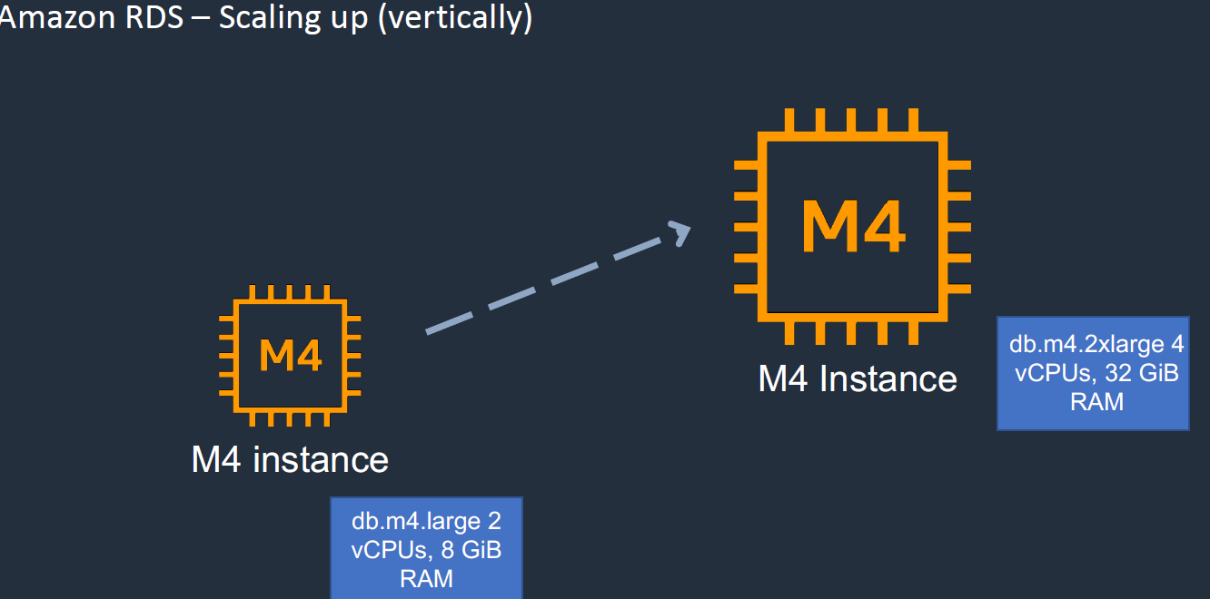

As we know that if want to change instance type any time then we can change it. Let’s say the instance where the RDS is installed is running out of memory then in this case we can go to higher configured EC2 instance without any down time. Because AWS automatically created the image of master database and hence to avoid downtime we can connect to the backup RDS and once the higher configured instance is ready we can again connect to our main RDS database.

**The other way of scaling the RDS is to scale out horizontally**.

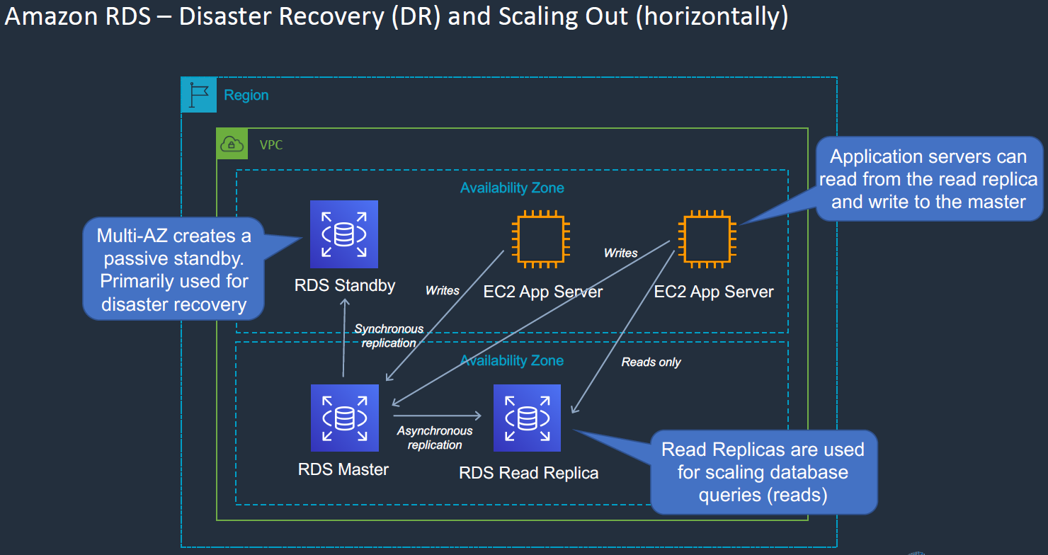

As shown in the image, we have multiple Availability Zone; the master RDS database is available in one of the AZ from where the application is reading / writing data so it is live database. Further this master database is synchronously replicating data into another standby RDS database which is available in different AZ. (Here Synchronous replication means the master data base once replicate database into standby RDS database, then Master RDS receives response from the standby RDS database ,just to confirm that data has been replicated into standby RDS). This very good way to make sure that our database is very consistent, but we have to wait until standby RDS sends acknowledgement to Master RDS so in this case it is bit. Now if from any reason Master RDS database gets failed then the Standby RDS database can be used as master data for read/write for application. So standby RDS is a passive standby and primarily used for disaster recovery.

So in the scaling up we have changed the EC2 instance with high configured instance from the low configured EC2 instance and which was nothing but scaling up vertically. Now in case of horizontal scaling out, we add an additional database and this called read replica, means this database would have only read only permission and this database would be Asynchronous where acknowledgement is not required from the replica database. So in this case Master RDS database will be having read/write permission but the replica RDS database would be having only read access only. So in this way we can increase the RDS performance at least in case of read data from the database for the application which are firing queries to get data only.

**Creating Amazon RDS in multi-AZ.**

Now let’s create Amazon RDS in multi availability zone. Here we are going to launch one Master RDS database, another one standby passive RDS and third one is replica of master RDS with read-only access. Let’s go to Amazon management console. > Database> RDS

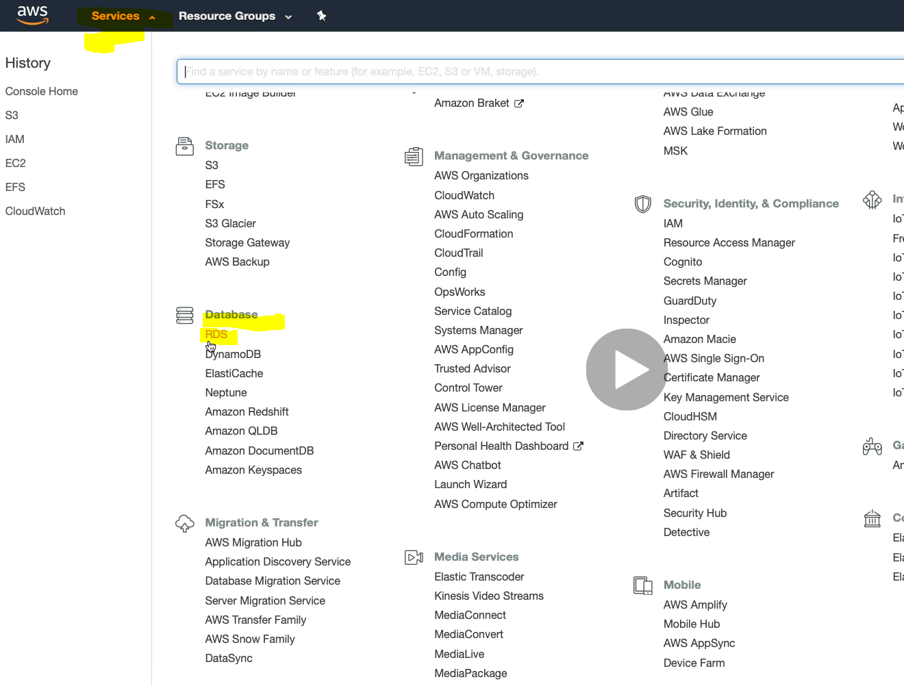

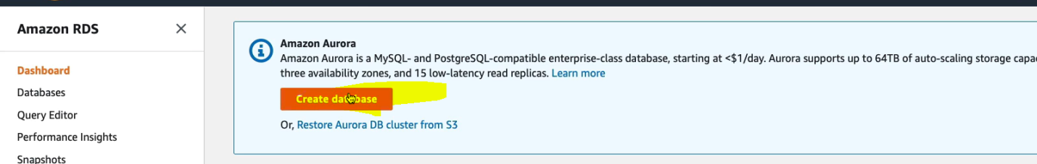

|  |  |
| --- | --- |
|  |  |

By default in the Engine type Amazon Aurora is selected but let’s go with MySql database and select the version from the community. Further in this page below we need to select template and we will select free tier.

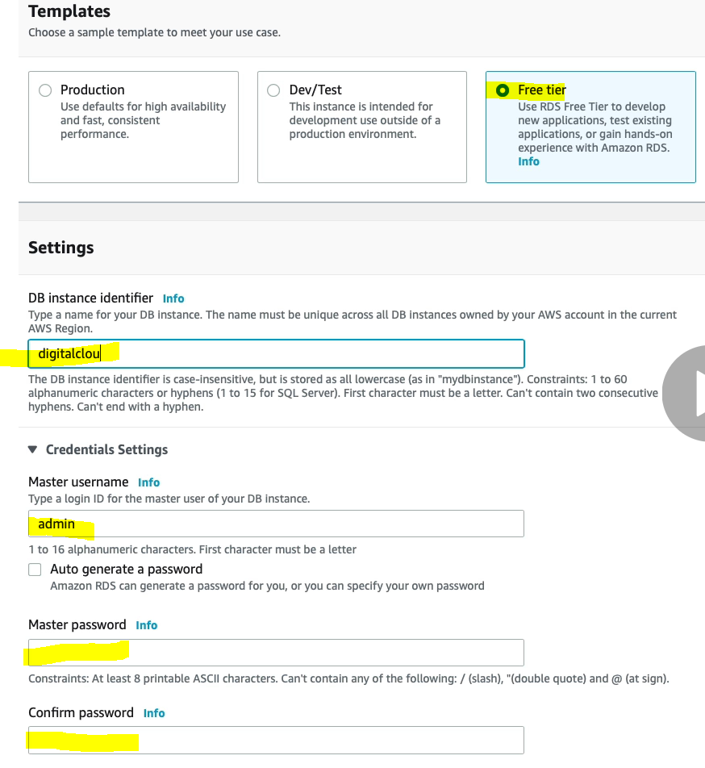

Finally click on create Database button.

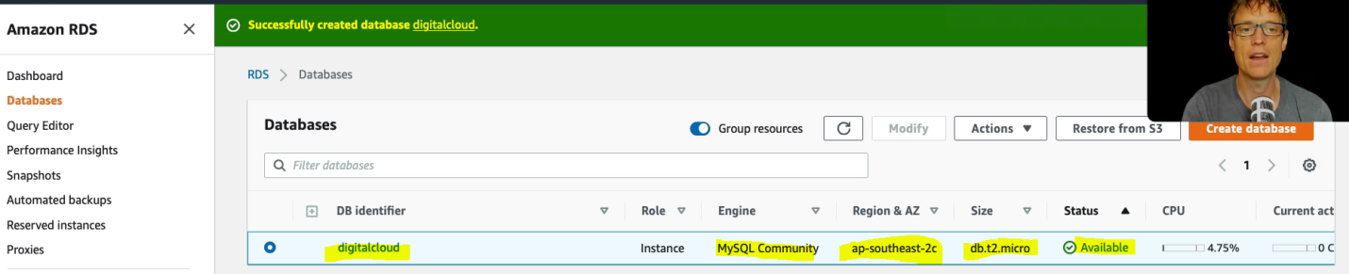

On right top corner click on view credential.

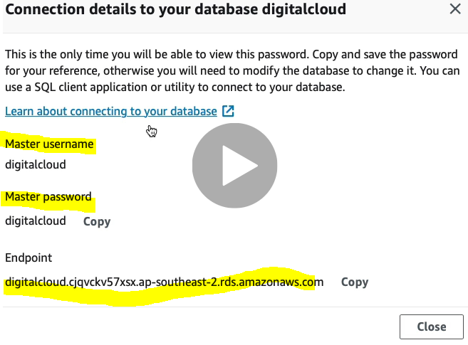

This end point we will use in our application to connect database. And to get more info click on database name.

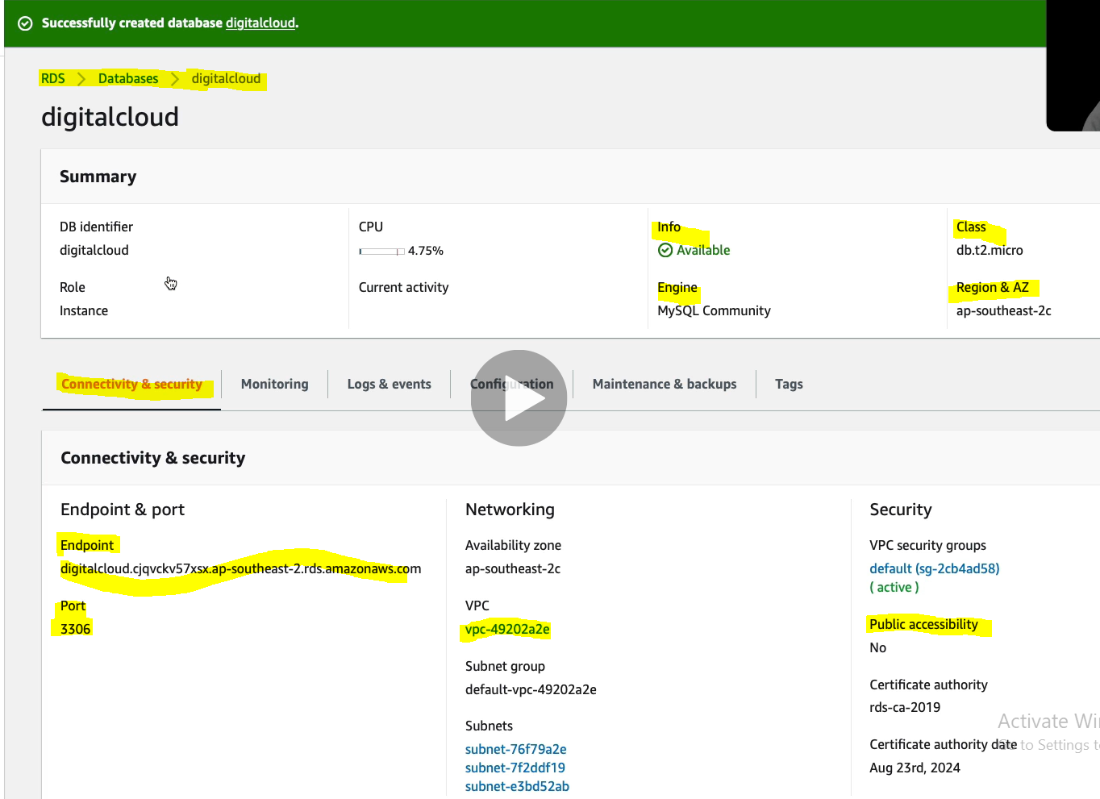

It is very important mention the security group while launching RDS database, so that our application can talk to our RDS database at port 3306. Now to veriyfy, let’s go to security group and add security group the database engine.

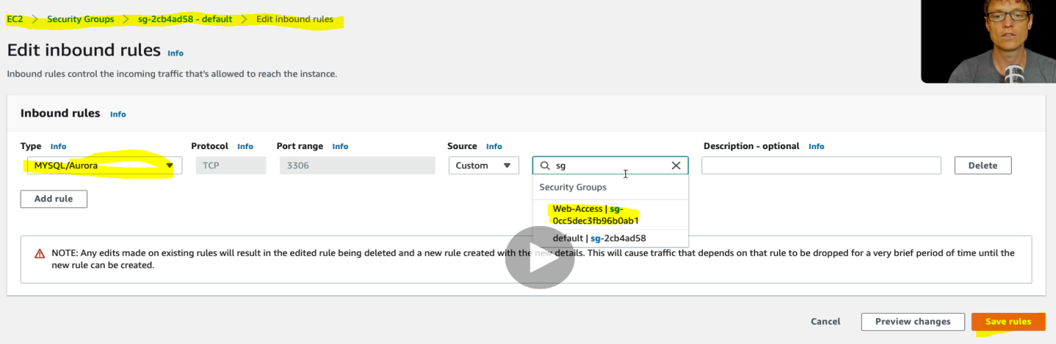

So it more secure that using default security group assigned database engine.

Here if in the RDS screen if we go to Maintenance & Backups then for “Auto minor version upgrade” is enabled and for this no downtime is required. But for bigger changes we need to select maintenance window downtime.

For enabling multi AZ.

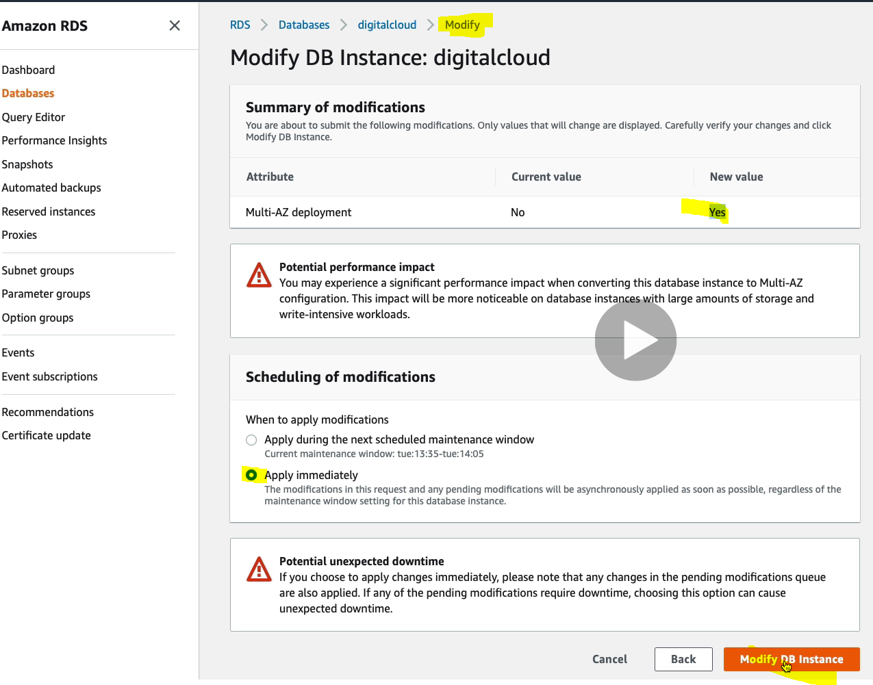

**Add an Amazon RDS Read Replica**

Go to RDS>Database>our own database(digitalcloud) > click Action> click create read replica

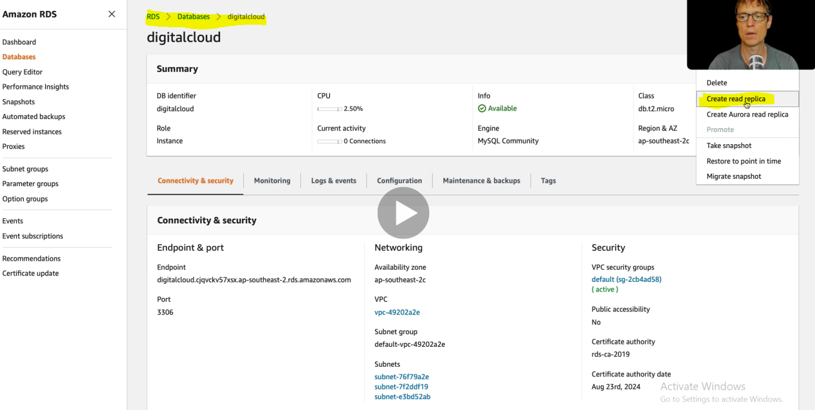

Since it is separate database instance

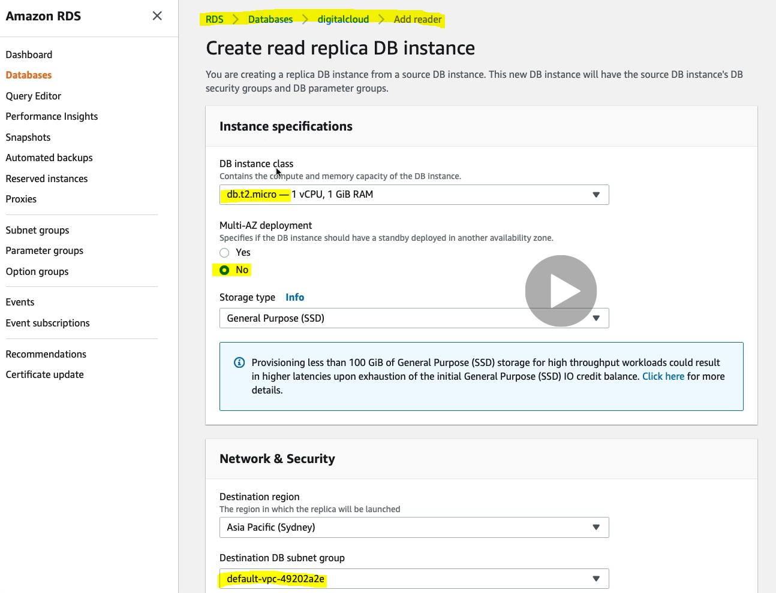

Now let’s go back to database and we will see two one master and another one is read only (ro) replica of RDS in two different availability zone.

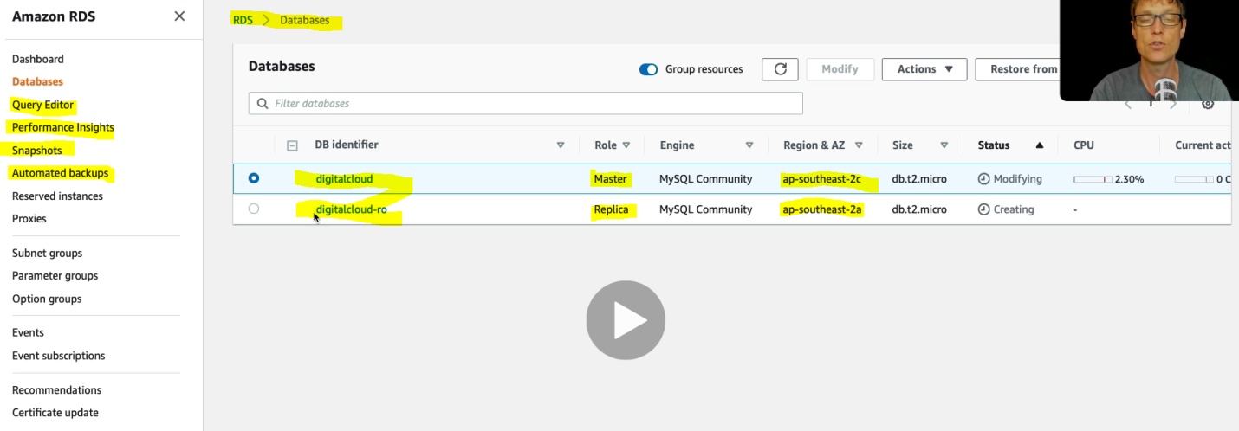

Apart from this we can do some more action like Automated backups and by default the automated backup time is 5 min away from the original master database and another one is snapshot just like EC2 instance snapshot done in the previous class.

Now let’s go inside read only database where we will see a different endpoint to connect with the application

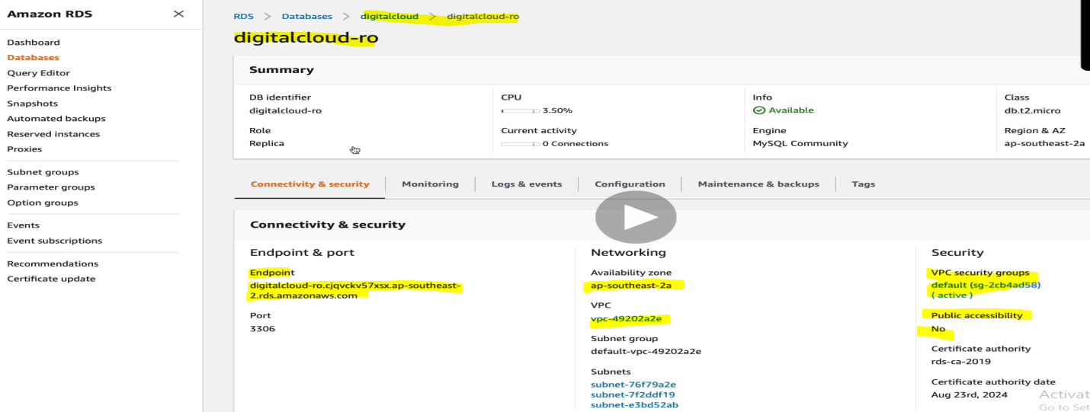

Hence we will have one connection string for main master database having read and write access and we will have different connection string for replica database having only read only access.

**Install WordPress on EC2 with RDS Database**

Here we are going to install WordPress into EC2 instance and then will connect this WordPress to the RDS database.

For this let’s go to EC2 management system and launch a new EC2 instance.

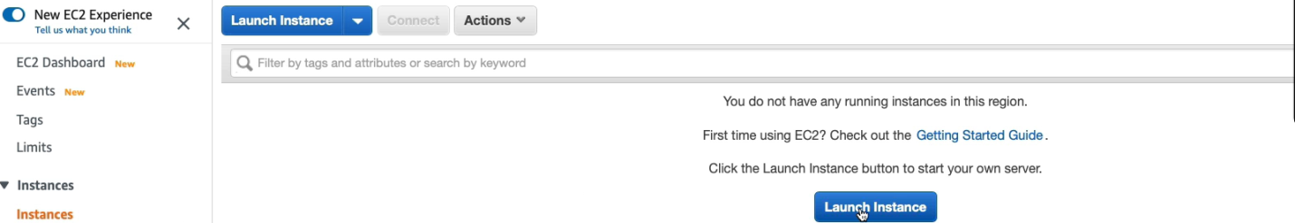

Let’s launch Linux EC2 instance using the same steps.

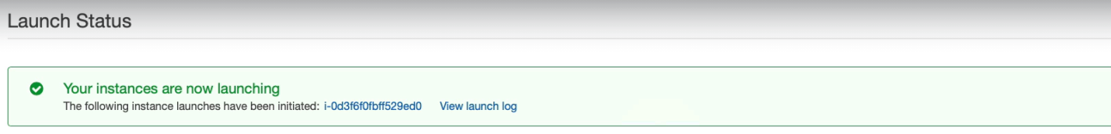

Now let’s connect this EC2 instance using with AWS CLI as shown below.

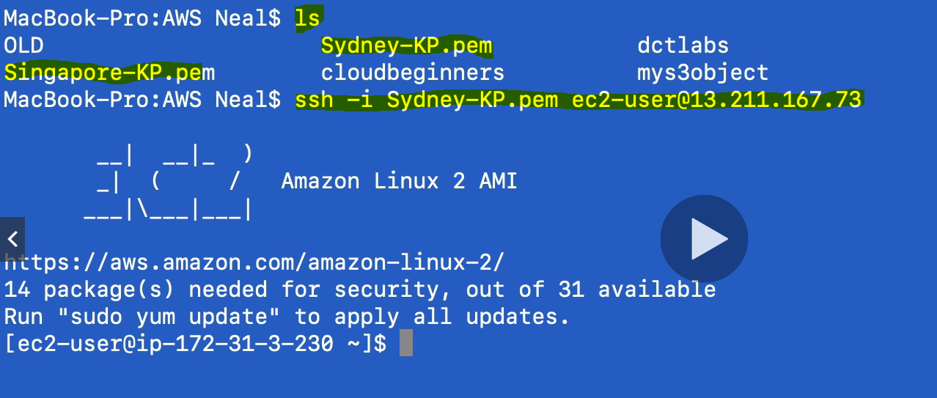

Here we have used KP file along with the public IP of the linux instance to connect linux EC2 instance.

Now to install wordpress we need to run some command as given below.

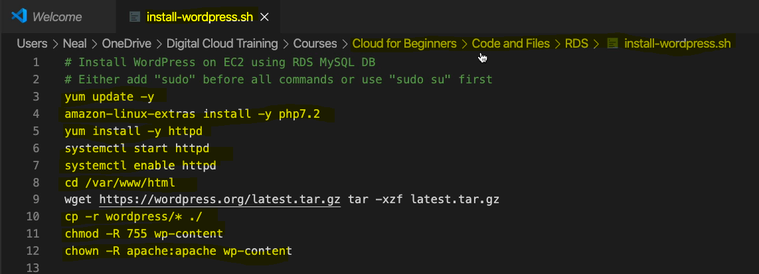

So as in the above screen shot it is mentioned that change the root user to sudo user before running command.

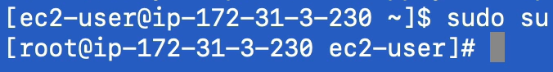

Now user is switched to sudo user.



Run this command to update Linux software repository to get latest software.

So now run all the command one by one as given below in the screen

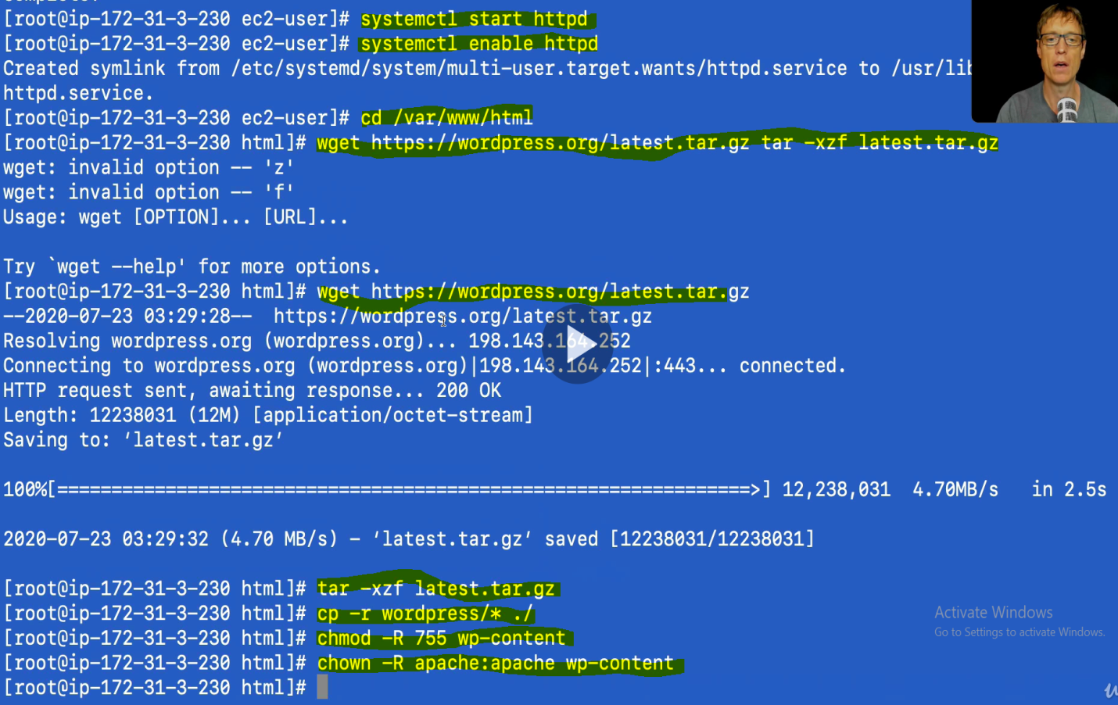

Now after running above command the wordpress should be ready to install in our EC2 instance.

Let’s go back to Linux EC2 instance and copy the public IP

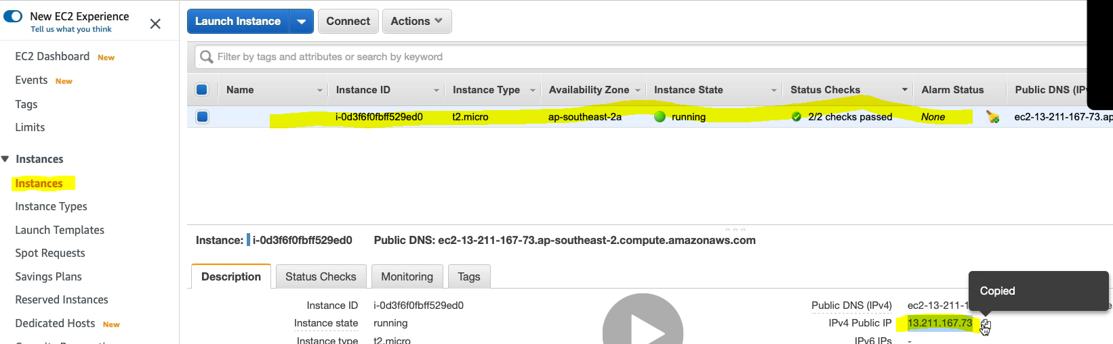

Now put this ip address on the browser and see

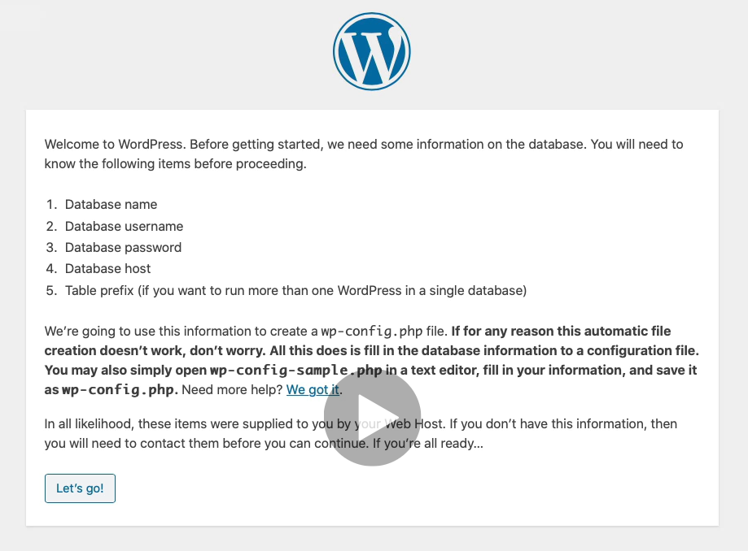

And this is what we have got after running ip address into the browser.

Click on let’s go!

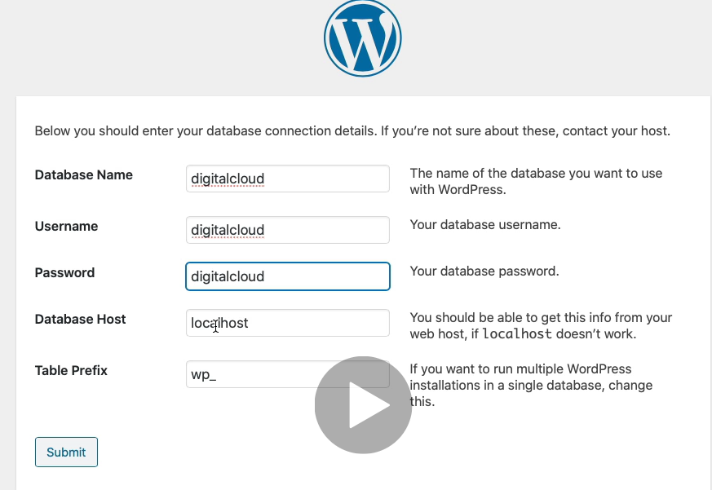

In the database host we have to provide RDS connection URL. So let’s go to RDS database and copy connection URL.

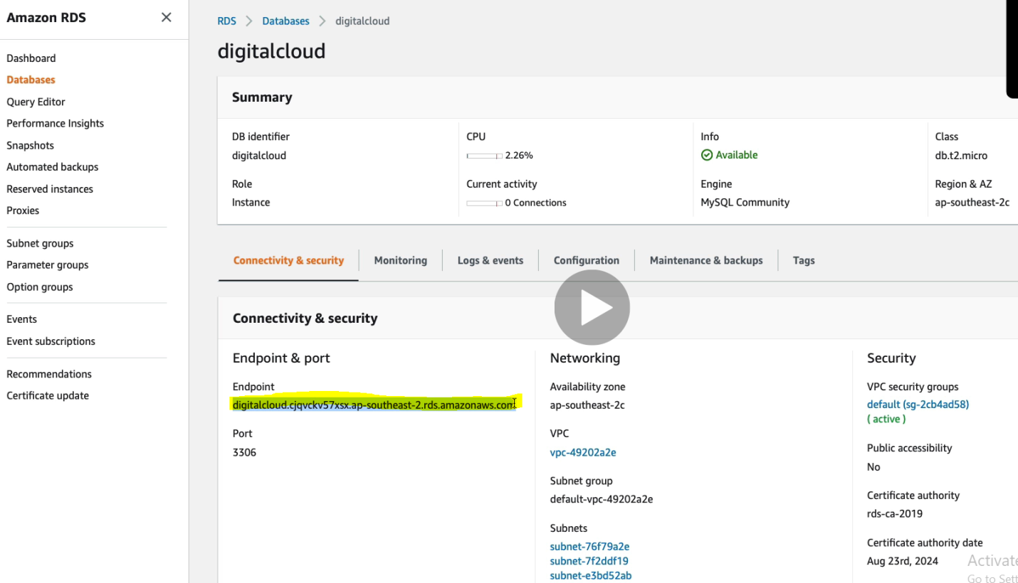

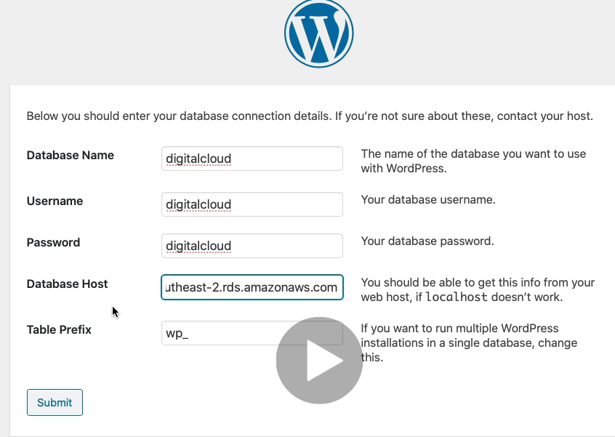

But before submitting this we need go to security group and check whether we have mapped correct SG or not to allow access. At the current moment the database is mapped to default security group that we can see above screen under VPC Security Group. Now let’s change it to our created SG

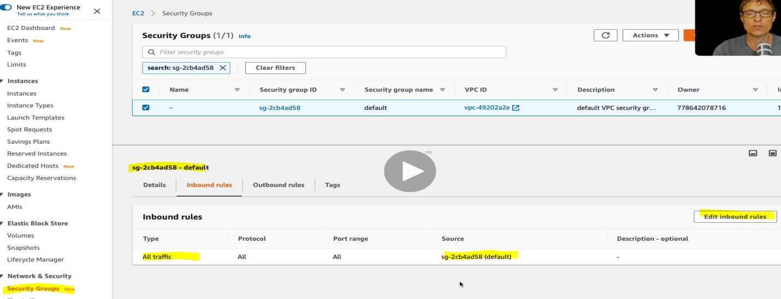

So as we can see that the default SG allows all the traffic. So let’s add our EC2 instance to the SG

Click on the Edit inbound rule> remove the default SG and our created SG (Web-Access)

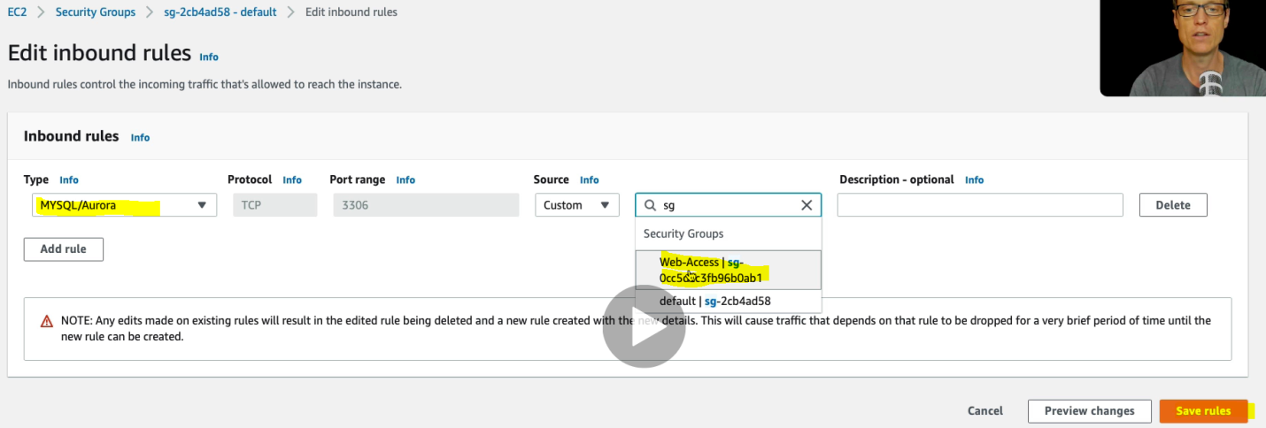

So now it will allow all the traffic access on 3306 port. Now let’s go to EC2 instance just to make sure that this SG Web-Access is assigned to EC2 instance .

EC2 >Actions> Networking> Change Security Groups

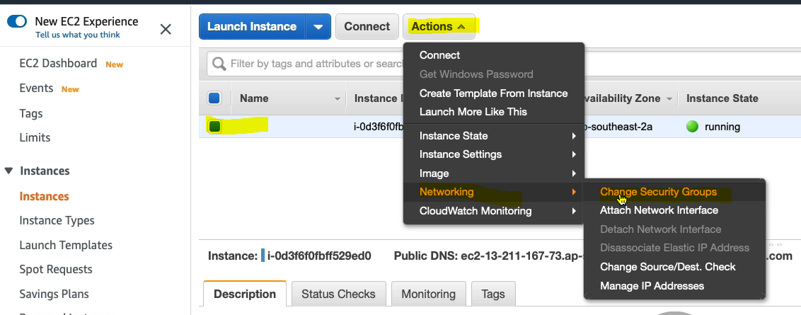

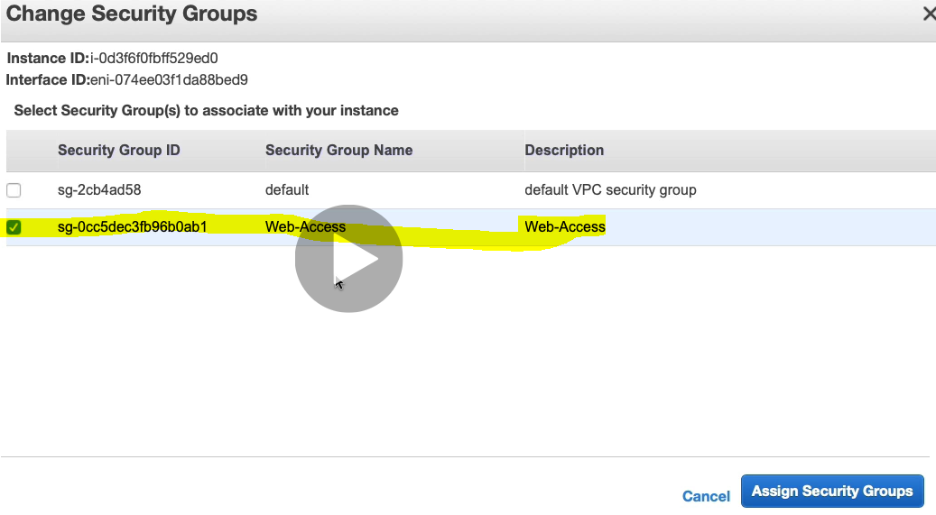

And yes, now the EC2 machine is assigned to Web-Access group only. Now let’s go back to WordPress screen and click on submit

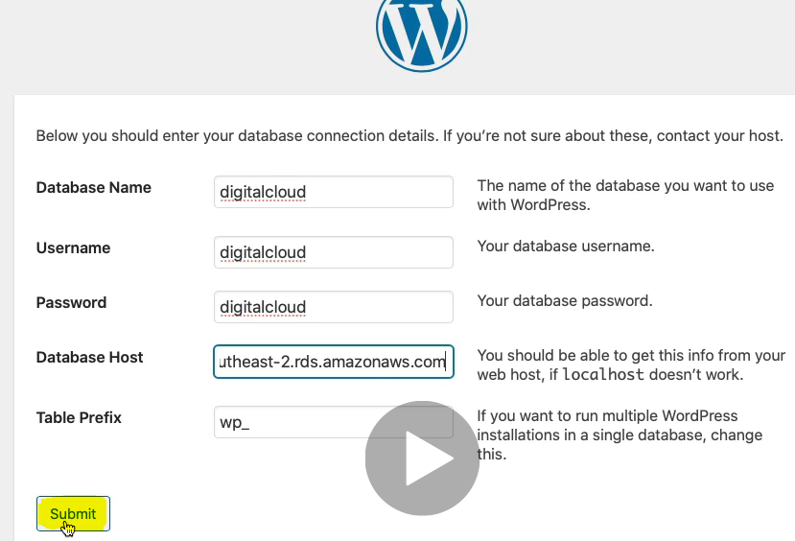

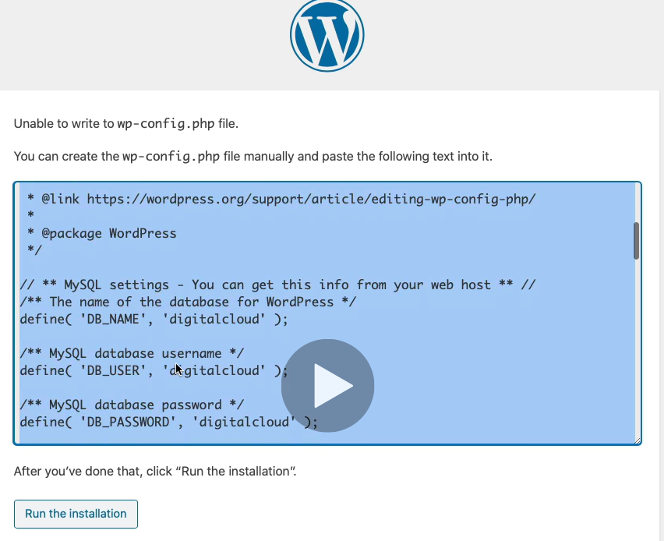

So the highlighted part is the configuration file , which include all the information about MySql database. So copy this content and create a file with the name of wp-config.php as mentioned above in the screen

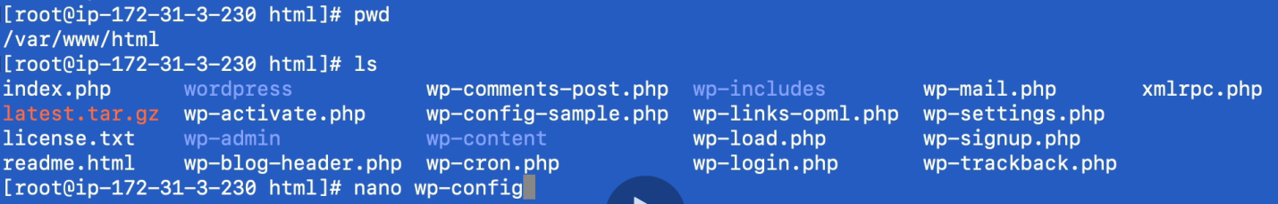

Create the file in this present work directory (PWD) using nano command.

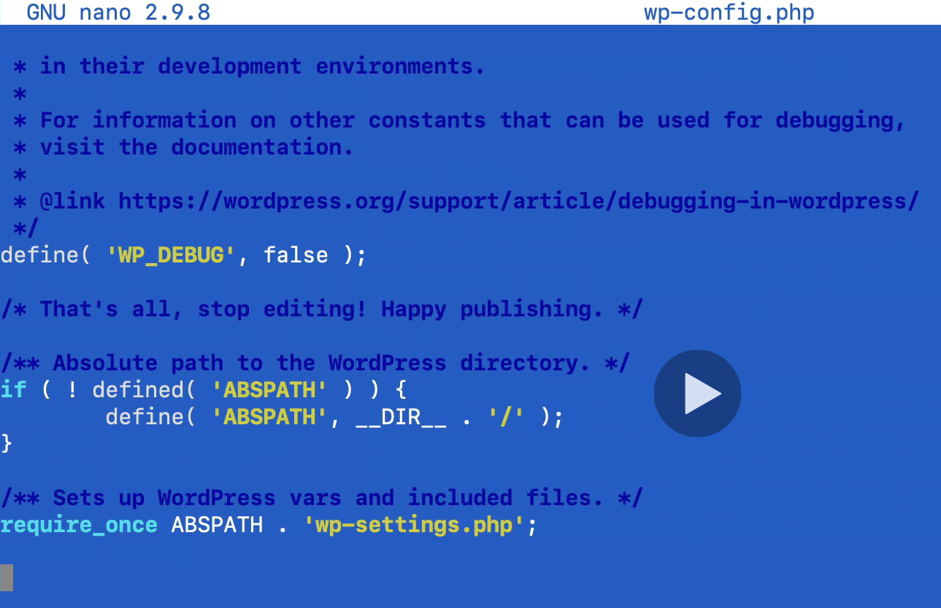

Save this file content.

Now go back to WordPress screen and “Run the Installation”

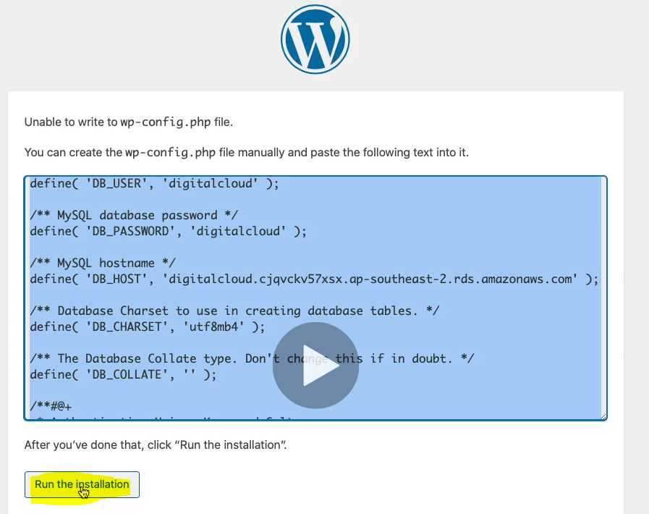

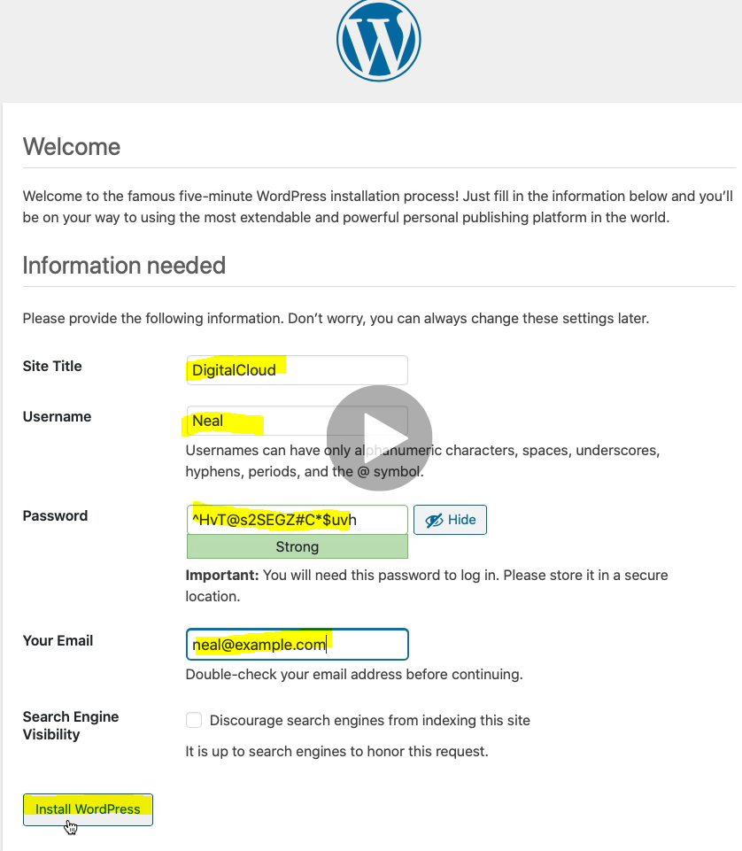

Click Install WrodPress and we got the WordPress welcome Hello world page as given below.

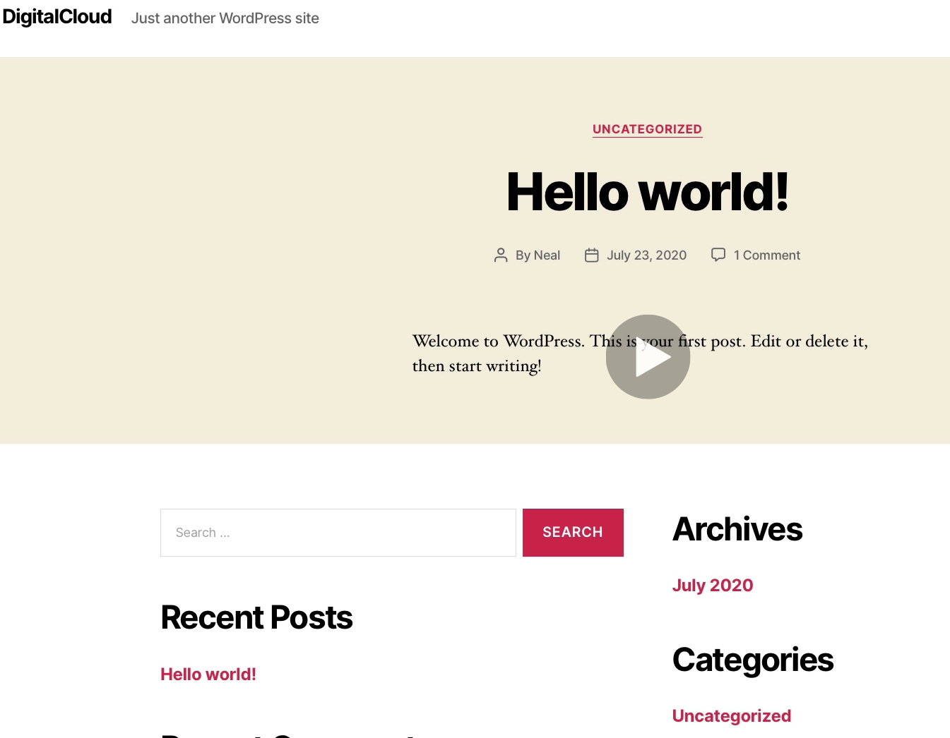

So this way we have installed WordPress into EC2 instances. And we can use RDS database for this WordPress.

**Amazon DynamoDB:**

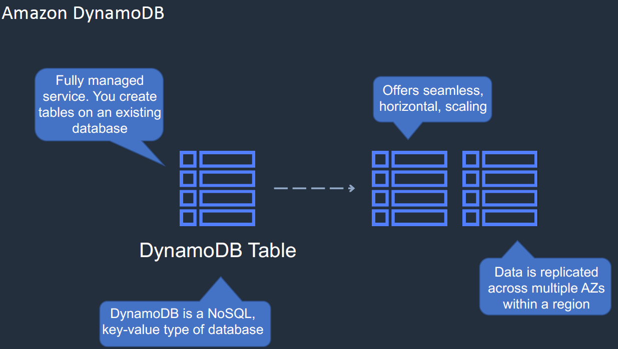

1. It is the database Amazon itself, means they have created this.
2. It’s a fully managed service and here instead of creating database, we need to create table in the existing database.
3. It’s a non-relational, No-SQL key-value type of database. In this way we get lot of flexibility on the schema and attribute associate with the database.
4. It can be scale horizontally and it is known as seamless scaling, i.e. we will not get any system downtime if we scale this database, and thus data is replicated across the multiple AZs within a region.

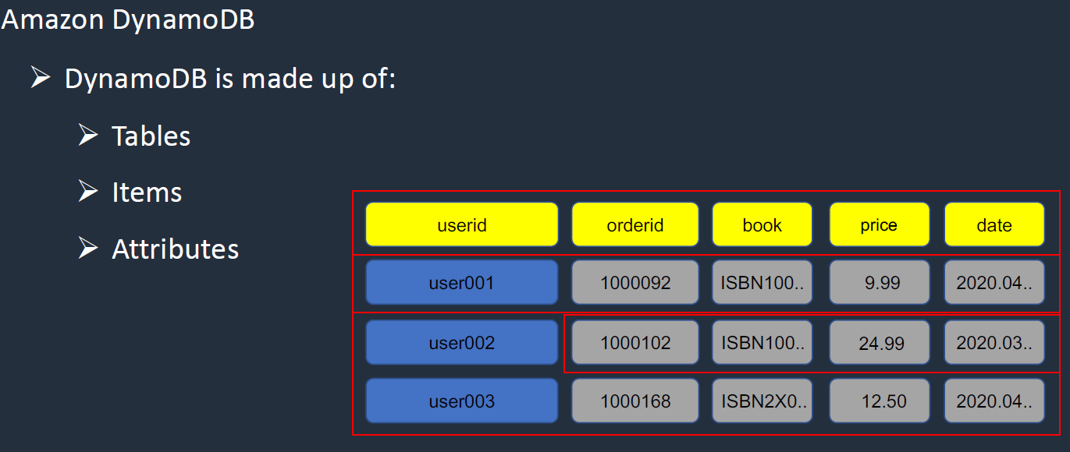

So as shown in the above image, DynamoDB is made up of

Table: Under the table we will have Items

Items: Items is nothing but the rows of the table.

Attributes: Attributes is associated with Items.

Now let’s create the DynamoDB in AWS.

Go AWS management console > Services> Database> DynamoDB

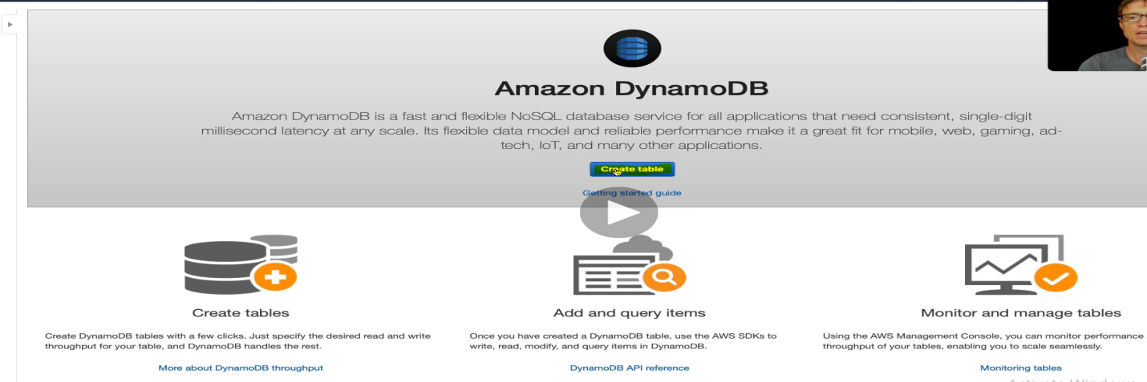

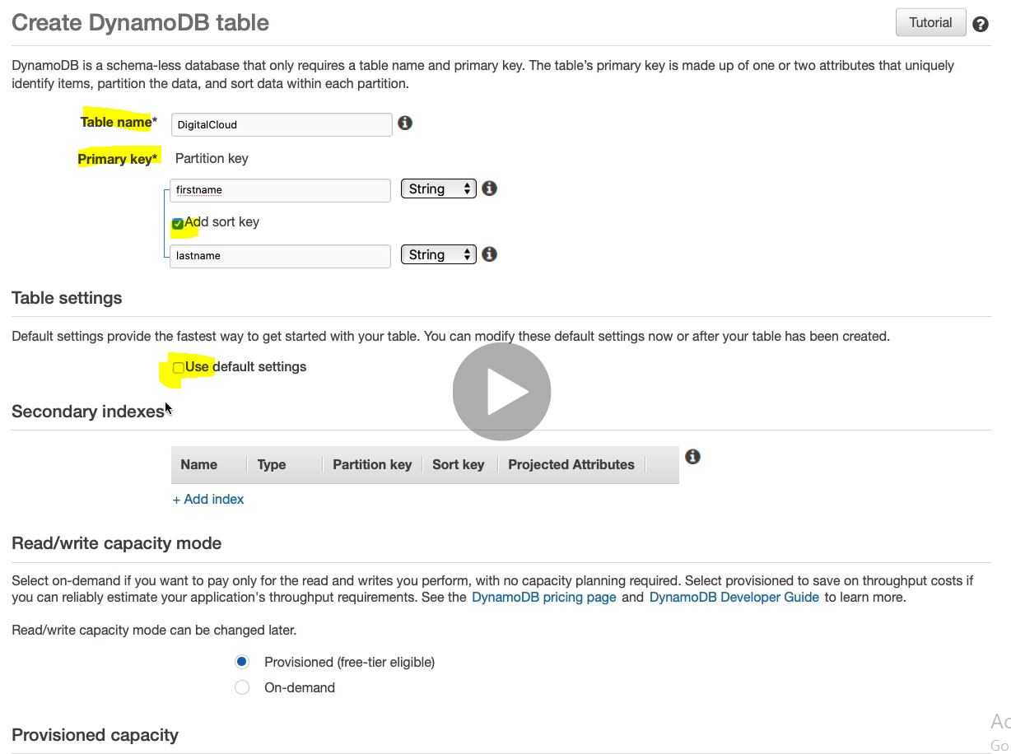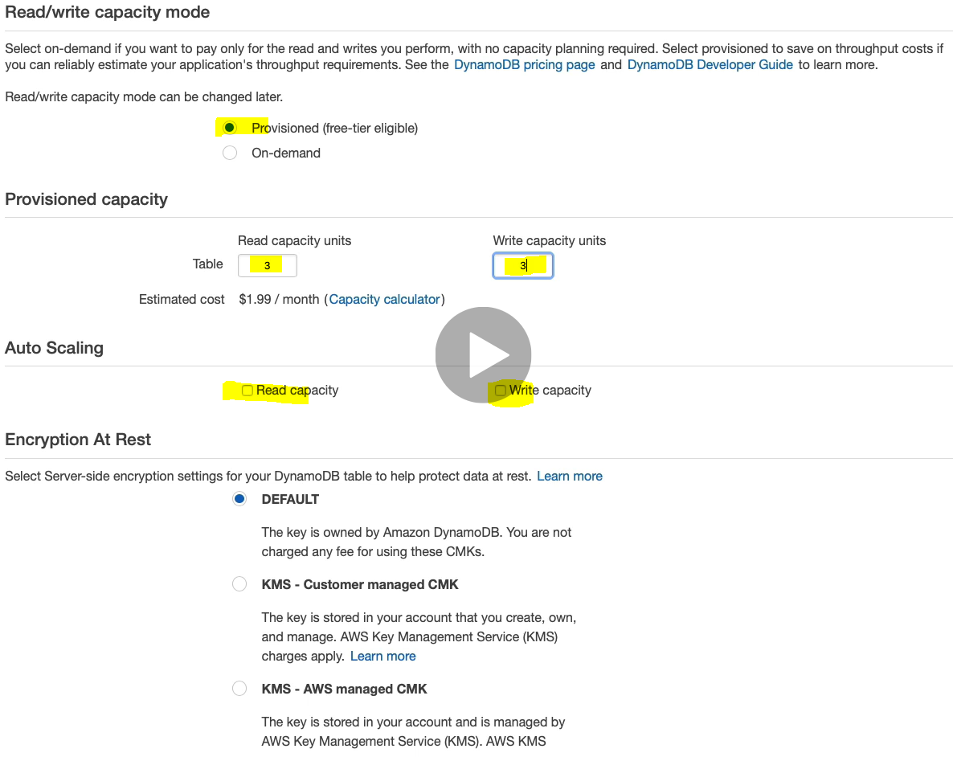

Click on Create button to create.

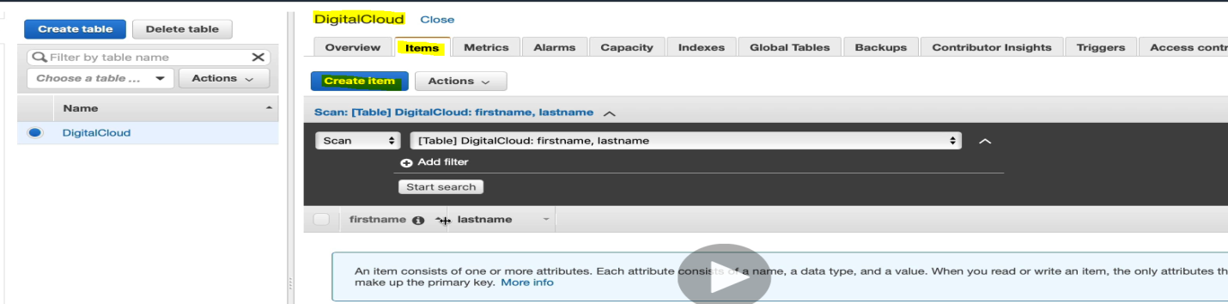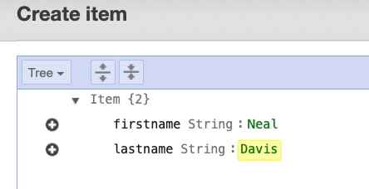

Click save and the we will get the value inside table.

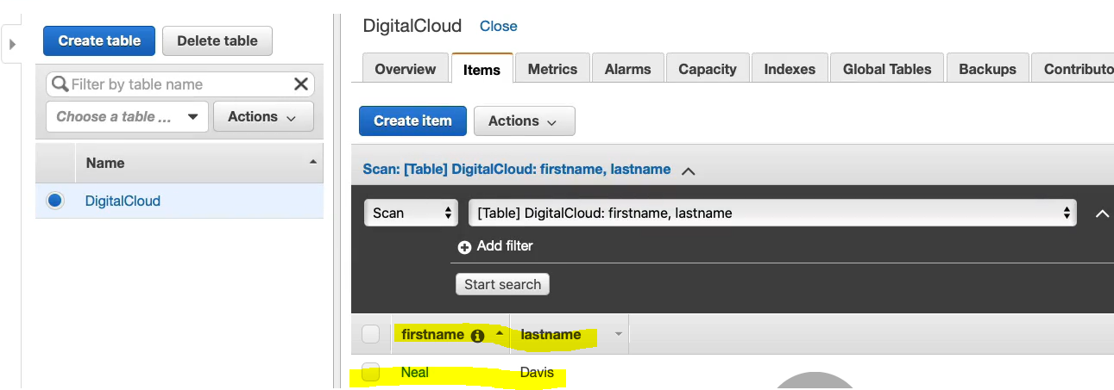

|  |  |
| --- | --- |
|  |  |

We can append the columns and attribute in the table. Like we have added employeeid (number) in the first row (Neal). To append just click on Neal row and will get option to edit item (row).

Now

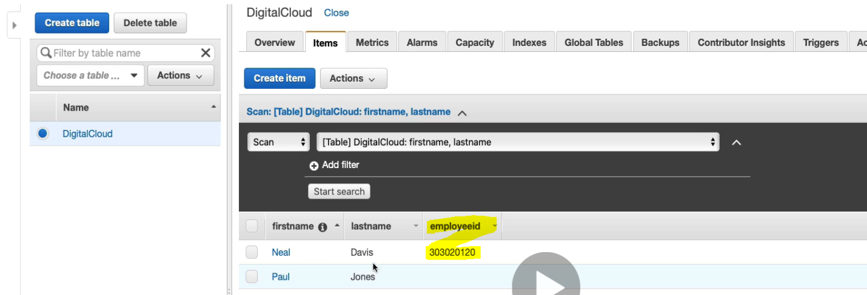

Hence we can add any attribute in the item.

Let’s create another table. Click Create Table.

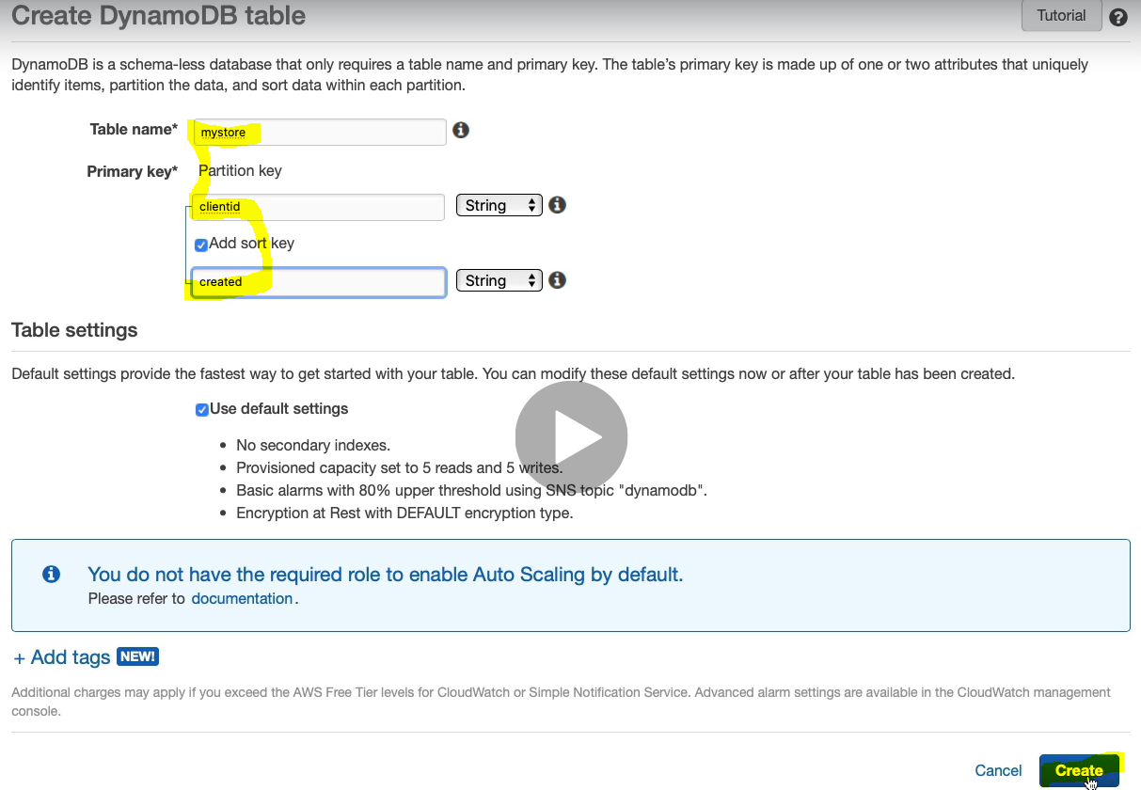

Now let’s import the data into Dynamo DB from the outside, and for that we have to run some command as shown in the below image

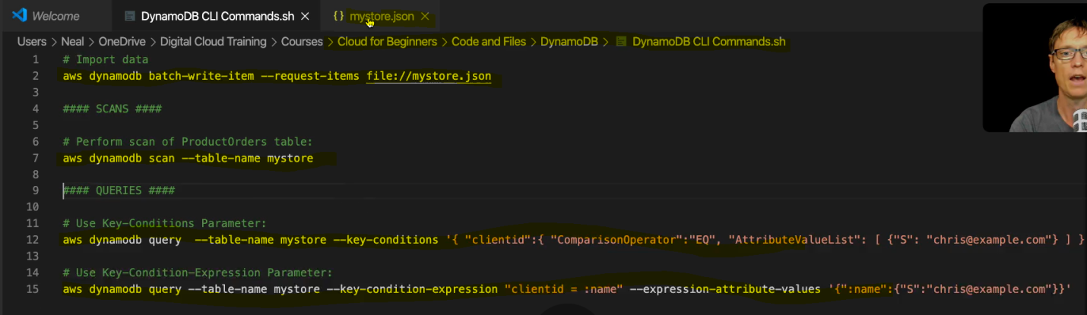

Before running the first command, just make sure that the file which contains the data to be imported will be placed into the current directly. Use ls command to check



So yes, we have mystore.json is available in the current directory.

Now the first command

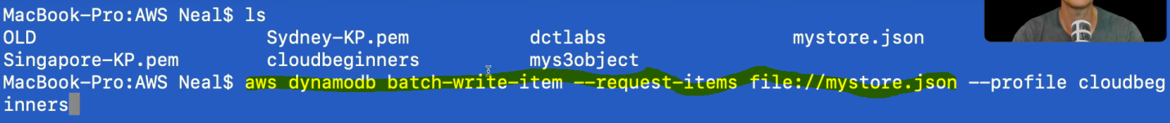

Here profile is given to just identify the user name profile which is not required if you have logged in with this profile. After running the above command we will get the response like that

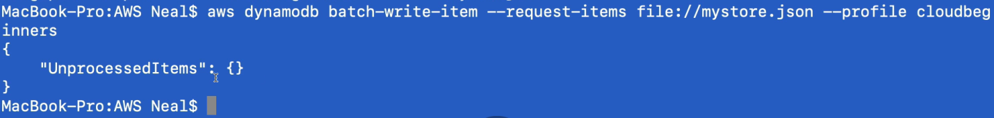

Which means there is no data to be process, all data is now imported. Now let’s go back to the table and check.

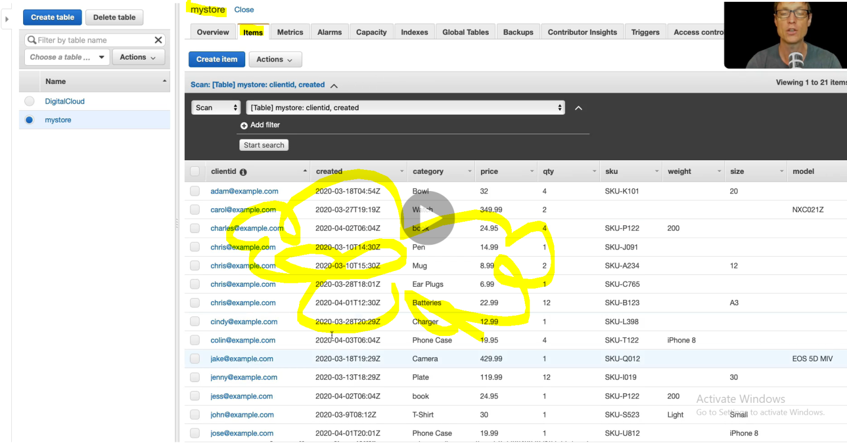

So yes now the data got inserted into the table.

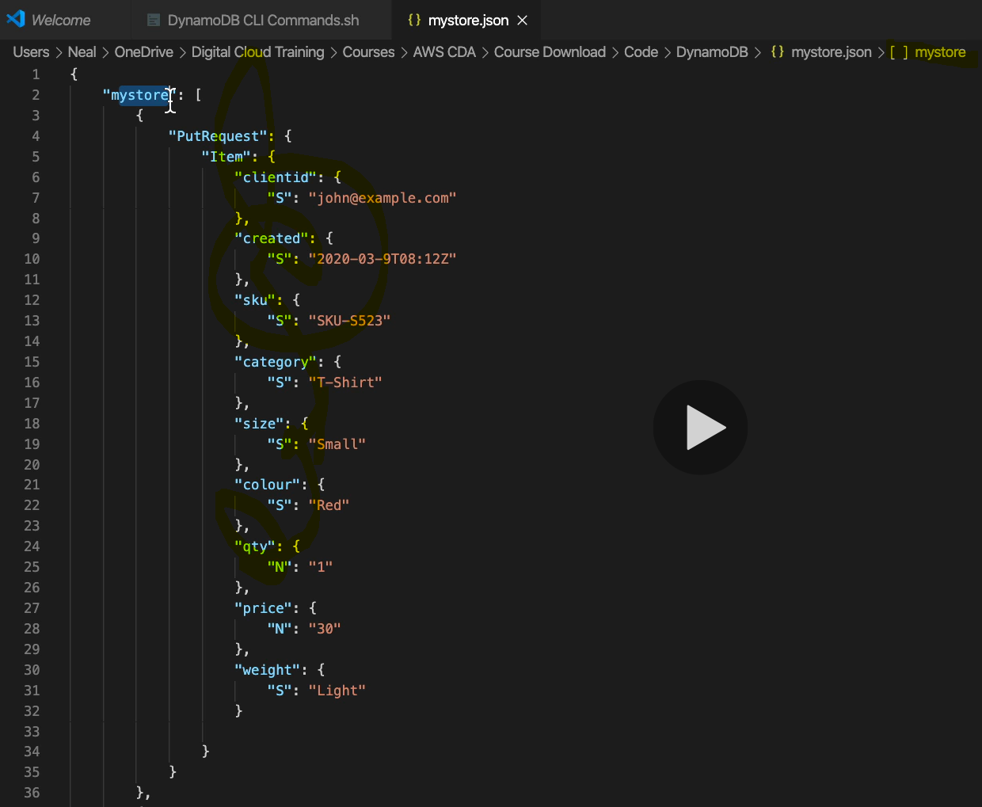

This is the Table name and item that we have written or imported into Dynamo DB

Searching Table and Item:

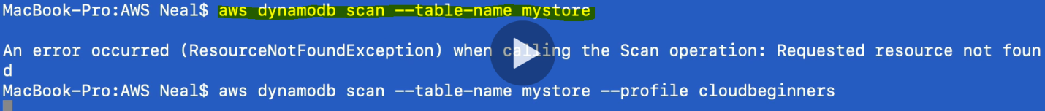

The above command is searching or scanning the table name mystore.



This is the specific query with key condition to get particular item from the table.

Similarly the query written above can be used to create, import table data and query for searching items and data from the table.

Automation on AWS: Will see later as here we will have to run script on the CLI to launch EC2 instance, Storage bucket, file etc.

**DevOps on AWS:**

DevOps is very important for the developer and operation team for CICD.

**Continuous Integration Continuous Development in AWS:**